Directions: The goal of the following problems is to help challenge and deepen your understanding of the current topic. Don’t assume that you will know how to answer each and every question. You will work with at least two other students in the class to try and find solutions and write arguments for each of the following questions. Be sure that you question your classmates’ reasoning. If you don’t understand how they are getting something you should ASK THEM TO EXPLAIN! Being able to defend your reasoning is important and so you are actually helping them by asking them to explain.

Challenge Questions

- Answer the following limit questions showing full justification.

- Create three limits that all have the form of but produce the answers of , 0, and.

- Kyle is trying to answer the following questions and presents the following work to his professor. Why is Kyle’s work incorrect or insufficient to justify his answer?
- .
Here Kyle is doing two things incorrectly. First, he appears to be “plugging-in” infinity which can’t be done since infinity is not a number. Second, he is asserting that infinity/infinity = infinity which is not true. Infinity/infinity is an indeterminate value and therefore we cannot assess its value.

- .
Kyle is taking an approach here that we typically only use with limits where . Note that the in his work would not evaluate to be 0 when .
- Evaluate the limit providing full justification.

.
We then note that if , then we can assume that and therefore . So we have that

- Determine the horizontal and vertical asymptotes to

A vertical asymptote would occur at x values where the denominator equals 0 and the numerator doesn’t equal 0. We see that . Therefore, there is a vertical asymptote of
Horizontal asymptotes of the graph can be found by computing .
We calculate that

Therefore has two horizontal asymptotes: .

- Determine the horizontal and vertical asymptotes to .
Horizontal asymptotes of the graph can be found by computing .
We calculate that
and this limit DNE.
Therefore has a single horizontal asymptote of .

Recall the limit laws that we discussed in class.
Theorem: Suppose that c is a constant, n is a positive integer and the limits and exist. Then,

- TRUE or FALSE: If neither nor exists, then must not exist. If the statement is true provide a justification demonstrating that it is true. If the statement is false, provide a counter-example that shows the statement is false.

FALSE: Consider the functions and and let . Clearly DNE but and therefore exists.

- TRUE or FALSE: If does not exist then it must be the case that either or do not exist. If the statement is true provide a justification demonstrating that it is true. If the statement is false, provide a counter-example that shows the statement is false.

TRUE: Notice that if the statement was false then it would be the case that both & exist and yet DNE, however this directly contradicts the limit law that we have which states that if & exist, then which implies that must exist.
Now we turn to some more atypical questions to challenge or understanding of the topics of this chapter thus far.

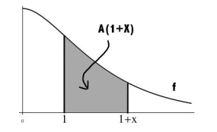
- The function f is continuous and decreasing on . Define to be the area from 1 to under the graph of f and above the x-axis (as shown in the picture below).

Compute . Hint:
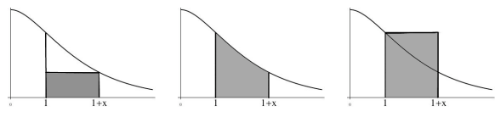

We see that and this implies that . We note that and . Therefore, by the Squeeze Theorem, it must be the case that .

- Is there a value of a such that exists?

We see that . If the numerator is divisible by then the limit will certainly exist.

We calculate that

To makedivisible by it must be the case that the remainder is 0 and therefore we need

So, if then

